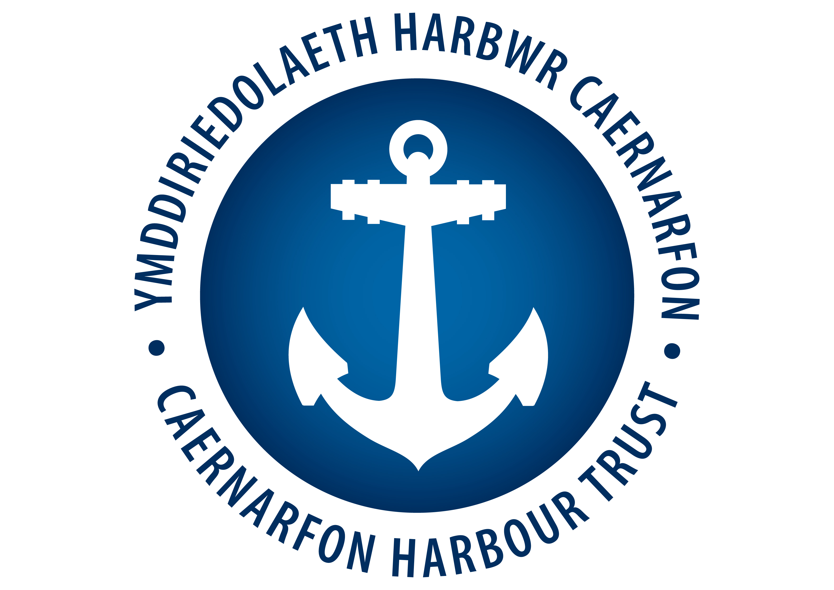
YHC – EVENTS APPLICATION FORM - CHT

1. | The Proposed Event:
2. | Date and time of the Event:
3. | The Event Organiser:
4. | Address:
5. | Contact Telephone Numbers  / VHF Channels and call signs:
6. | Give a brief description of the geographical limits within which the event will be staged
7. | Have you arranged Public Liability Insurance to cover the event?  If so, please attach a copy
8. | Has the event been publicised?  If so, please include details
9. | Are the following Agencies aware of the proposed event? (please tick as appropriate)
9. | Holyhead Coastguard |  |  |  |  |  |  |  |  |  |  | Police |  |  |  |  |  |  |  |  |  | Local Authority
9. | Harbour Master |  |  |  |  |  |  |  |  |  |  | Local Yacht Clubs |  |  |  |  |  |  |  |  |  | Plas Menai
9. | Have you sought the advice and assistance of the above agencies?  If so, please indicate to what extent
10. | Have you carried out a risk assessment? If so, please attach a copy
11. | Your estimate of the number of participants the event will attract |  |  |  |  |  |  |  |  |  |  |  |  |  |  |  | Your estimate of the number of visitors the event will attract
12. | Are there specific event rules the participants are asked to comply with?  If so, please attach a copy
13. | Please indicate who in your organisation is responsible for the Safety measures considered necessary to support the event (include address and contact number)
14. | Please indicate which of the following safety features you will implement:
14. | Event Rules |  |  |  |  |  |  |  |  | Safety Boat |  |  |  |  |  |  |  |  |  |  | Emergency Plan
14. | On Site Medical Assistance |  |  |  |  |  |  |  |  | Radio Communications |  |  |  |  |  |  |  |  |  |  | Monitoring Weather Conditions
14. | Other Safety measures:
15. | The above information is accurate to the best of my knowledge and I undertake to inform the Harbour Master immediately of any changes
15. | Signed  (Event Organiser) |  |  |  |  |  |  |  |  |  |  |  |  |  |  |  |  |  |  | Date:
Please return the completed form to:
hm@harbwrcaernarfon.org.uk
The Harbour Master, Harbour Office, Manton St Helens road, Caernarfon, Gwynedd LL55 2PF
Tel: 01286 875 355
For Office Use Approval:

Event Authorisation Terms

We hereby authorise the event, and in issuing authorisation the applicant ___________________________ ___________________________ will be required to agree with the following terms;

- The applicant will indemnify Caernarfon Harbour Trust against any claim that may arise from the event, resulting in either damage to property due to the applicant's negligence, or injury to personnel however caused.

- The applicant shall indemnify Caernarfon Harbour Trust against any liability, loss, claim or proceedings arising in respect of any loss or damage caused to Property by the negligent act or omission of yourselves or your agents, employees or invitees. For the avoidance of doubt, you agree that you do not limit your liability in respect of any injury or death as a result of your negligence.

- The applicant is responsible for all of their employees and guests and for any equipment associated with the event.

- The applicant is responsible for all health and safety matters relating to the Event and its participants.

If appropriate and if opportunity arises, the applicant shall mention the name of Caernarfon Harbour Trust in any Credits or additional advertising literature/broadcast associated with the event.

Please sign to intimate your acceptance of the above terms.

Signature

___________________________________

Print Name

___________________________________

Date

___________________________________

